Module 3: Personalize Customer Experience Dynamics 365 Marketing

Hands-on Lab Step-by-Step

September 2021

Contents

Personalize Customer Experience using Dynamics 365 Marketing 1

Lab Prerequisites 1

Scenario: ContoTech Worldwide Enterprise Retail Company 1

Goals for this lab 2

Exercise 1: Create Dynamics Segment 2

Task 1: Access Marketing Apps 3

Task 2: Create contact records 3

Task 3: Create a Dynamic Segment 5

Exercise 2: Create Marketing Emails 8

Exercise 3: Create Customer Journey (Basic) 8

Exercise 4: Experience Real Time Event Based Marketing – Customer Journey Orchestration 8

Copyright 9

# Personalize Customer Experience using Dynamics 365 Marketing

## Lab Prerequisites

Follow the pre-requisite steps that are included in the lab package. Before beginning this lab, confirm that you have provisioned a Dynamics 365 environment where you will save your apps, data, and other customizations with license to access Sales, Marketing, Customer Service with OmniChannels, Power Platform, Customer Insight, Teams, and Customer Voice.

Basic knowledge and familiar with:

1. Dynamics 365 Customer Engagement Fundamentals, Sales, Marketing, Services
2. Dynamics 365 Customer Insight
3. Power Platform

## Scenario: ContoTech Worldwide Enterprise Retail Company

Welcome to the ContoTech, No #1 in Technology! We specialize in all the IT enthusiasts’ needs; we offer variety of high-quality products from different reliable partners around the world, we operate more than 70 stores worldwide, during this pandemic we are committed to be the pioneer of digitally transformed IT retail company that is not only selling in traditional ways but also innovative ways to reach everyone everywhere with affordable high quality products with personalized experience for everyone.

Now, we have you as our newest IT consultant team member, we have no doubt that we will achieve our goals with you. As we continue to grow, there are multiple tasks are assigned to you to tackle our problems.

1. Multiple stores operate differently, and we have online stores, multiple social media connections, all of them will have different data produced by their own system/platform.
2. During the pandemic, we are focusing more to the online sales with personalized customer experience, we want to ensure we understand and have personal connection with our customers, we want to have centralized data that in the end we can have 360-degree customer view and understand their behaviors and recommend better, alternative, or new products, plus make some predictions.
3. After we get full view of our customers, we will then be able to accurately target and incorporate them into our customer journey with the right segmentation to keep them updated with our marketing activities and upcoming products or deals. Social media is one of our best lead generations so far.
4. We also have our B2B customers that we want to build relationship to secure deal with them
5. We are company with growth mindset, we open feedback anytime from anyone through multiple channels, we often communicate with our customers via social media, we believe that it will improve our services and quality and build our brand effectively, we want to have active Facebook page with dedicated customer service line that will monitor the cases closely and take necessary action to keep customers happy without feeling of being ignored.
6. We understand there are issues faced by our customers, we want to quickly take action and review the cases and dispatch our right available engineers to solve the issues effectively. We have variety of products we need to have system that can dispatch the right engineers.
7. We want to have dashboard with insight that will monitor and assist our talented customer service team, so we will understand their workload and we can reduce their workload by implementing automated and robotic seamlessly customer experience for frequently asked queries and occurred incidents.

Post sales services are very important to retain customers in this increasing competition, after every case is being closed, we want to improve our quality, so we openly receive feedback from the customers to hear their voices about our services / products.

1. While we love to have system with standard features that can meet our requirements, we open to any configuration and customization that can improve our team productivity, we want to have product visualization when our sales creating new opportunities or generating quotes for our customers.

In today exercise, we need you to focus on requirement #3, this will need you to focus on getting right target of audience and segmentation, run marketing activities and orchestrate customer journey against the targeted list.

## Goals for this lab

|  |  |  |  |
| --- | --- | --- | --- |
|  | After this lab you will be able to:   * Accurately target the right audience and segmentation for Marketing Activities * Plan, orchestrate, and execute Customer Journey, and automate it * Explore new feature of Real Time and AI powered Marketing |  | The time to complete this lab is [120] minutes. |

There are other features such as Email AB Testing, Spam checker, Event, Team Webinars, and Portal, and many more that you may want to explore outside this class

## Exercise 1: Create Dynamics Segment

The important decision when you are designing marketing activity is choosing the right audience, this will enable you to tailor your message to the best interest to the right group of contacts.

In Dynamics 365 Marketing, you'll set up a collection of segments, which you'll define by using terms that resemble those you already use to describe groups of customers, such as “Top spender”, “Female customers whose birthday is this month and have not purchased for sometimes”, “Customer who recently made complaints who lives in Singaapore”, etc. Then you'll use these segments to target marketing initiatives like email-marketing campaigns and customer journeys. Segments like these, which you define by using a set of rules and conditions, are called *dynamic segments* because membership in these segments changes constantly and automatically based on information in your database. (Static segments are populated by adding contacts explicitly, one at a time.). You can also get the segments from Customer Insight like the ones you have completed in previous lab, that you can easily export to the Dynamics 365 Marketing.

In this exercise, you'll create and use a couple of fictional contacts with email addresses that you can read, and then set up a test segment that includes those contacts. This test segment will be useful later when you begin to experiment with customer journeys.

#### Task 1: Access Marketing Apps

Go to Apps (at the top left, located next to Dynamics 365) list if you have not access Dynamics 365 Marketing Apps

Now, you are going to create dummy contact records

#### Task 2: Create contact records











1. Go to **Marketing** > **Customers** > **Contacts**. This takes you to a list of existing contacts. On the command bar, select **New**.

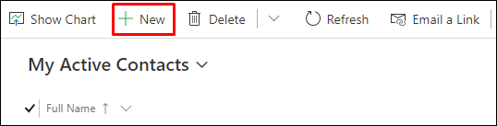

1. The **New Contact** page opens.

Fill out the following fields with fictional data and for the email, please use your own email address as it will be used to receive emails.

On the command bar, select **Save & Close**.

1. Create a second contact similar to the one you just made. Use the same email address and fictional city, but use a different first and last name.

Now, you have 2 contact records, this is the time to create the segment

#### Task 3: Create a Dynamic Segment

1. Go to **Marketing** > **Customers** > **Segments**. This takes you to a list of existing segments. On the command bar, select New.
2. **New** opens into a dropdown menu, allowing you to choose either a **New Dynamic Segmen**t or a **New Static** **Segment**. We're going to create a segment that finds all contacts from our fictional city, **Singapore**. So, select **New Dynamic Segment**.
3. The **Segment Templates** dialog box opens; select **Skip** to close it and continue to the **New Segment** screen.

1. Enter the name of the Segment and then Add Query Block

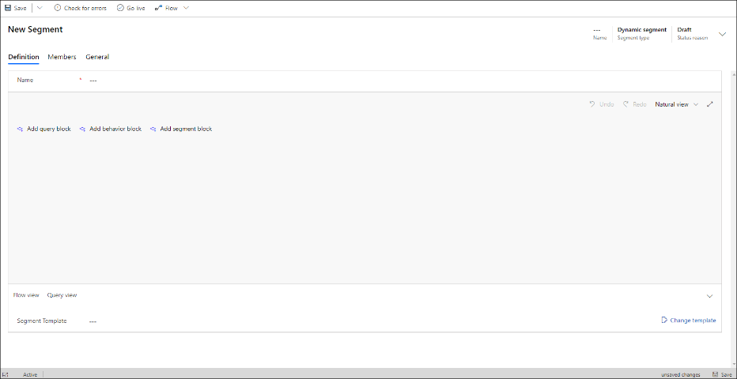

1. Select **Add query block** to create a query against the contact entity. You can see the entity being queried by checking the value shown on the drop-down list at the top of the query block.  
   Graphical user interface, text, application, email

   Description automatically generated

By default, the new query block creates **Contact** based query with a new row. Your segment currently includes no filters (clause rows), which means it will find all the contacts in your database. But we only want to find the new test contacts that we just created, so let's add a filter.

1. The row starts with a field containing the ghost test **Select attribute**. Select this field to open a drop-down list that shows all attributes available on the contact entity. Then type "city" to filter the list and choose **Address 1: City** from the list.

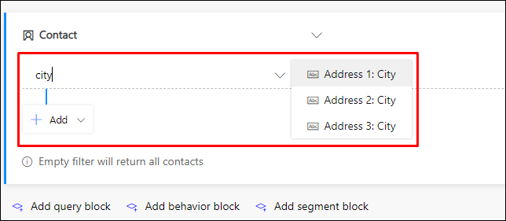

1. Two new drop-down lists are now added to the row. Leave the next drop-down list set to **Equals**. This is the operator, which defines the way we are going test values in the **Address 1: City** field of the **Contact** entity. Other operators include **Contains**, **Begins with**, **Contains data**, and more, depending on which type of value (string, number, date, and so on) you are working with.

Select the third drop-down list, which contains the ghost text **Enter text** and type the fictional city name that you chose for your test contacts (such as "Singapore" if that's what you chose).

1. Select the **Name** field at the top of the query and enter a name for your segment (such as "Contacts in Singapore").
2. Select **Save** on the command bar to save your segment and then select **Go Live** to publish the segment (you won't be able to use it in a customer journey until it goes live, even though you've saved it). Marketing checks the segment for errors and reports any problems it finds. If an error is reported, fix it and try again. If no error is found, your segment is copied to the marketing services, which make it available for use by a customer journey.

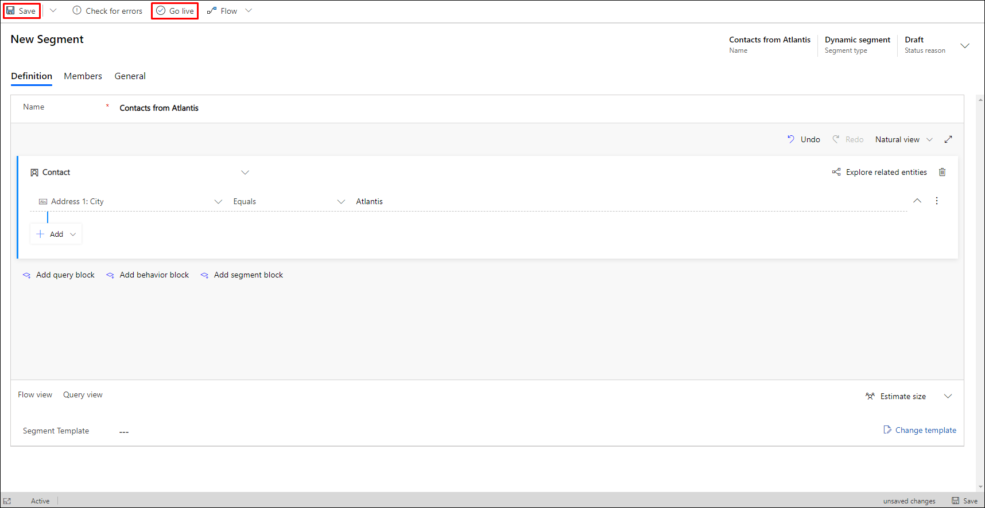

1. Wait for about a minute and then select **Refresh** on the command bar to refresh the page. You should now see that a **Members** tab has been added (if you don't see it, wait a little longer and try to **Refresh** again until you do). When the **Members** tab appears, open it and note that your segment includes the two fictional contacts that you added earlier.

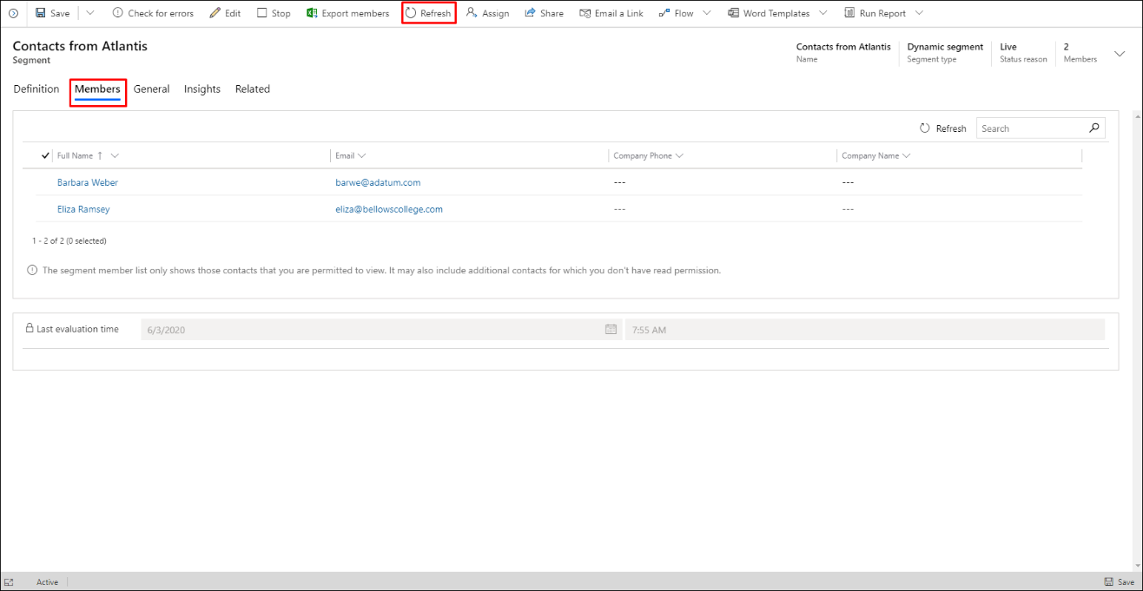

**Note:**

You can build very complex queries by using the tools here, creating rows and groups combined with AND clauses and OR clauses, and adding more query blocks that you can combine using Union, Exclude, or Intersect operations. You can even query based on properties of other entities, but each query must ultimately end with the contact entity because segments must always result in a group of contacts. Though segments can't contain lead or account records, you can design your segments to find contacts associated with these types of records. For more, see Working with segments

## Exercise 2: Create Marketing Emails

*To be added

## Exercise 3: Create Customer Journey (Basic)

*To be added

## Exercise 4: Experience Real Time Event Based Marketing – Customer Journey Orchestration

*To be added

# Copyright

© 2021 Microsoft Corporation. All rights reserved.

By using this demo/lab, you agree to the following terms:

The technology/functionality described in this demo/lab is provided by Microsoft Corporation for purposes of obtaining your feedback and to provide you with a learning experience. You may only use the demo/lab to evaluate such technology features and functionality and provide feedback to Microsoft. You may not use it for any other purpose. You may not modify, copy, distribute, transmit, display, perform, reproduce, publish, license, create derivative works from, transfer, or sell this demo/lab or any portion thereof.

COPYING OR REPRODUCTION OF THE DEMO/LAB (OR ANY PORTION OF IT) TO ANY OTHER SERVER OR LOCATION FOR FURTHER REPRODUCTION OR REDISTRIBUTION IS EXPRESSLY PROHIBITED.

THIS DEMO/LAB PROVIDES CERTAIN SOFTWARE TECHNOLOGY/PRODUCT FEATURES AND FUNCTIONALITY, INCLUDING POTENTIAL NEW FEATURES AND CONCEPTS, IN A SIMULATED ENVIRONMENT WITHOUT COMPLEX SET-UP OR INSTALLATION FOR THE PURPOSE DESCRIBED ABOVE. THE TECHNOLOGY/CONCEPTS REPRESENTED IN THIS DEMO/LAB MAY NOT REPRESENT FULL FEATURE FUNCTIONALITY AND MAY NOT WORK THE WAY A FINAL VERSION MAY WORK. WE ALSO MAY NOT RELEASE A FINAL VERSION OF SUCH FEATURES OR CONCEPTS. YOUR EXPERIENCE WITH USING SUCH FEATURES AND FUNCTIONALITY IN A PHYSICAL ENVIRONMENT MAY ALSO BE DIFFERENT.

**FEEDBACK**. If you give feedback about the technology features, functionality and/or concepts described in this demo/lab to Microsoft, you give to Microsoft, without charge, the right to use, share and commercialize your feedback in any way and for any purpose. You also give to third parties, without charge, any patent rights needed for their products, technologies and services to use or interface with any specific parts of a Microsoft software or service that includes the feedback. You will not give feedback that is subject to a license that requires Microsoft to license its software or documentation to third parties because we include your feedback in them. These rights survive this agreement.

MICROSOFT CORPORATION HEREBY DISCLAIMS ALL WARRANTIES AND CONDITIONS WITH REGARD TO THE DEMO/LAB, INCLUDING ALL WARRANTIES AND CONDITIONS OF MERCHANTABILITY, WHETHER EXPRESS, IMPLIED OR STATUTORY, FITNESS FOR A PARTICULAR PURPOSE, TITLE AND NON-INFRINGEMENT. MICROSOFT DOES NOT MAKE ANY ASSURANCES OR REPRESENTATIONS WITH REGARD TO THE ACCURACY OF THE RESULTS, OUTPUT THAT DERIVES FROM USE OF DEMO/ LAB, OR SUITABILITY OF THE INFORMATION CONTAINED IN THE DEMO/LAB FOR ANY PURPOSE.

**DISCLAIMER**

This demo/lab contains only a portion of new features and enhancements in Microsoft Power Apps. Some of the features might change in future releases of the product. In this demo/lab, you will learn about some, but not all, new features.